1. **Avasarala, Venkata Bhardwaj**
2. **Team D – Phoenix**
3. **Client:** Dr. Michael Oudshoorn ([oudshoorn@nwmissouri.edu](mailto:oudshoorn@nwmissouri.edu) )
4. **Project:** Project Management Collaboration Tool
5. **Team Role:** Communications and documentation management
6. **Weekly Iteration plan**:

I have been assigned the role of Client Management and I’m responsible for meeting with a client, give updates and get requirements from client.

**Tasks to be accomplished this week:**

In this week, I would be working on the functional specification of the project and would discuss the specifications of the project with my team and add any new specifications as required in the project suggested by the team. I would also design the prototype for the application that were pending after the last week’s presentation.

**Labor hour estimate:** I would be working for 38-40 hours this week to accomplish all these tasks. I may even spend more 4-5 hours if necessary to reduce the lag that’s currently existing in the project.

1. **Last Week Accomplishments:**

I worked for around 39 hours in the last week and I have contributed my part in designing the project management plan and preparing the Gant Charts. I have also gone through the different Functional specification documents and have documented functional specifications for chatting.

**8. What is the riskiest component under the development?**

The riskiest component is finding the functional specifications and documenting it.

**9. What active efforts are most critical for client acceptance or GDP completion?**

Finalizing the tools and platform is most critical task for client acceptance.

**Last Week’s Post:**

1. **Avasarala, Venkata Bhardwaj**
2. **Team D – Phoenix**
3. **Client:** Dr. Michael Oudshoorn ([oudshoorn@nwmissouri.edu](mailto:oudshoorn@nwmissouri.edu) )
4. **Project:** Slack/Hipchat collaboration tool
5. **Team Role:** Communications and documentation management
6. **Weekly Iteration plan**:

I have been assigned the role of Client Management and I’m responsible for meeting with a client, give updates and get requirements from client. The project is currently lagging in terms of project management plan and the use case diagrams, test cases and to get back to the track the team will be putting an additional effort and the tasks are divided accordingly between the team members.

**Tasks to be accomplished this week:**

In this week, 12% of the work would be completed as designing of the use cases and finalizing, documenting the requirements would almost be completed. I will also work on the project management plan with my team members to and design the Gantt Charts for the project.

**Labor hour estimate:** I would be working for 36-39 hours this week to accomplish all these tasks.

1. **Last Week Accomplishments:**

I worked for around 38 hours in the last week and I have researched the Google Drive API and its compatibility with different platforms. I have created projects in three platforms and tested its feasibility and its compatibility in different platforms. We have discussed the risk of some requirements like chat tool. I had a meeting with team and have decided after the discussion to encrypt the messages and were not sure to have a chat history backup or not and planned to discuss the same with the client. I also worked on the use case diagrams for the Google Drive integration.

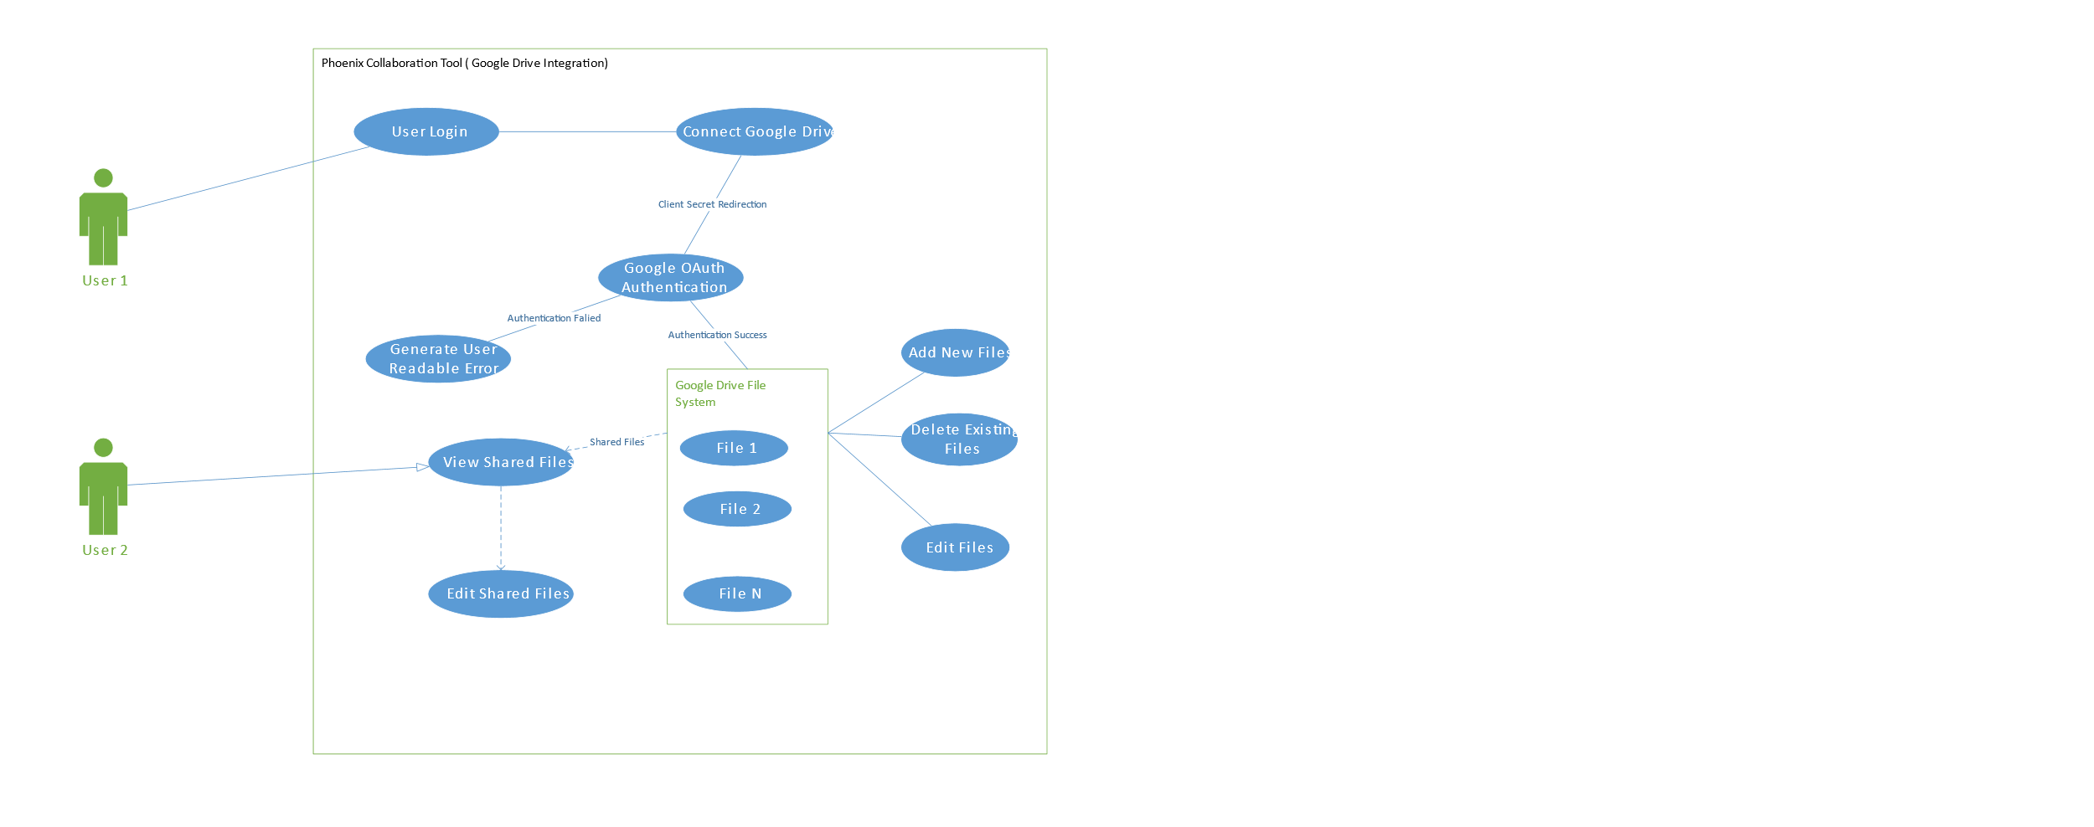

Figure : Use Case Diagram for Google Drive Integration.